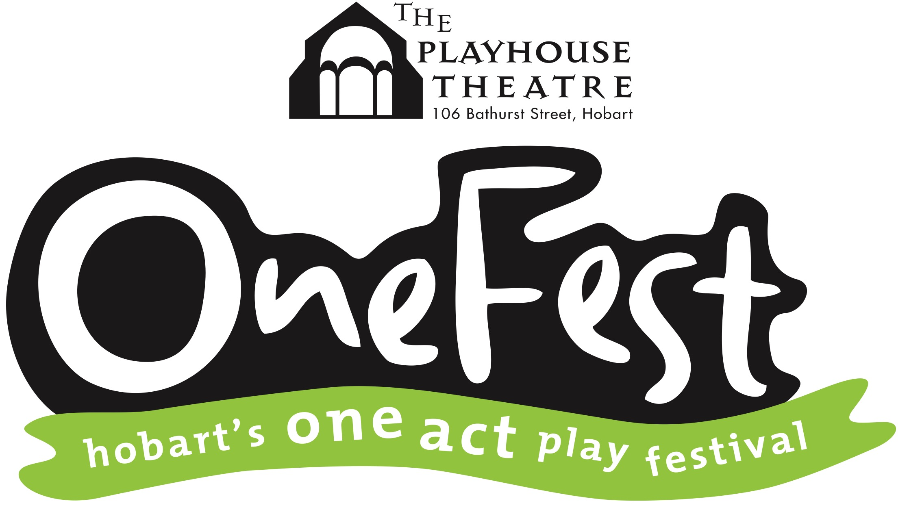

Terms & Conditions - OneFest 2024

Please read the below information before making your submission.

By making your submission you agree to be bound by these terms and conditions.

Production Requirements
- Plays must run for a minimum of five minutes and no longer than 30 minutes. Please make an accurate assessment about play length as overruns can upset schedules and impact adversely on other productions.
- OneFest take no responsibility for ensuring compliance with any copyright issues or the payment of royalties. This remains the responsibility of production teams.
- OneFest does accept plays with coarse language and/or adult themes, however, these MUST be clearly identified at submission. Please note: these plays will most likely be scheduled for an evening session.
- All production members must be aged 16 years or over at the time of the festival.
- OneFest accepts plays with solo performances.
- OneFest does not accept excerpts from full-length plays.

Fees & Submissions
- The deadline for submissions is 5pm Friday 20th September 2024.
- Entry fee is $50 for the first play, and $40 for each play thereafter
(please submit separate entry forms for each play).
- Payment by direct funds transfer is preferred. If you wish to pay another way, please contact the Programming Manager directly.
- The entry fee is non-refundable
- Electronic submissions are preferred. Submit via email to onefest@playhouse.org.au
If you wish to submit hard copies, please send two (2) copies of your play along with your entry form and payment to:
OneFest Programming Manager,
Hobart Repertory Theatre Society Inc.
PO Box 4650,
Hobart TAS 7001
- To ensure your play is accepted, we encourage you to submit your entry as soon as possible. Because of time restrictions across the three sessions, it may be necessary to cap entries.
- We’ll send a confirmation of receipt with advice regarding acceptance of your play into the festival via email.

Adjudication and Awards
- The adjudicator will give feedback on plays at the end of each session.
- Awards are merit-based. These awards are the adjudicator’s decision and announced at the conclusion of the festival on Saturday evening.
- The adjudicator’s decision is final. Entrants may seek informal feedback from the adjudicator but may not enter into conversation or correspondence regarding the awarding process or other decisions.
- Plays exceeding 30 minutes or running more than 5 minutes over their indicated length may be assessed at the adjudicator’s discretion but will not be eligible for awards.
NOTE: We understand that play running times can vary once rehearsals start. If your timing changes please advise the Programming Manager by Monday 30th September 2024. This will ensure you’re still eligible for awards.

Sessions
- Subject to change, sessions are currently set to commence at:
- 7.30pm, Friday 4th October 2024
- 2.00pm and 7.30pm, Saturday 5th October 2024
- If sessions need to be reduced the Friday evening session may be removed first.
- Actors and directors are given free entry to all sessions of the festival. These passes are not transferrable. We ask that you do not give them to other people.

Technical
- Each play will be allowed a maximum 15 minute tech run in the week leading up to the festival. Entrants will be advised of the specific details in the week of the festival by the Stage Manager. Tech runs are not an opportunity for a full run of your show – limited time is available so please use the time for technical purposes only.
- Lighting, Sound, and staging requirements must be kept very simple. OneFest reserves the right to simplify technical plots if they are too complex. The Stage Manager will contact the entrant prior to the tech runs to confirm requirements.
- OneFest provides lighting and sound operators. Entrants are not permitted to provide their own technicians.
- The theatre hire agreement is a basic one. Any additional requirements such as projectors may incur an additional fee. If this is the case, we’ll discuss it with you first.
- Use of wet, sticky, or flammable substances on stage is highly discouraged and must be cleared with the Stage Manager prior to tech runs. Smoking and naked flames are not permitted at The Playhouse Theatre.
- The Playhouse Theatre has limited storage therefore entrants must ensure all staging and properties are removed from The Playhouse at the conclusion of their session.

These Terms and Conditions are correct at time of publishing. OneFest reserves the right to update them at any time.

